WK1-PM1

Cybersecurity Lab Setup
VirtualBox and Kali Linux

Student name | Ezekiel AROM
Student ID
Course / module | Project Module 1 (WK1-PM1)
Instructor
Submission date | 30/10/2026

Editable lab report template based on the supplied WK1-PM1 PDF. Replace bracketed prompts, add your own screenshots, and record only settings and results you actually completed.

1. Lab Task and Requirements
Task: Set up a cybersecurity testing lab environment on a laptop/PC using VirtualBox and Kali Linux.
☐ Use VirtualBox (latest recommended version).
☐ Set up Kali Linux as the attacking / testing machine.
☐ Create a NAT Network using subnet 10.0.0.0/24.
☐ Set Kali Linux IP address to 10.0.0.2/24.
☐ Enable clipboard and file drag-and-drop in the virtual machine settings.
☐ Enable shared folders and share the host machine’s /downloads folder.
☐ Ensure Kali Linux has full Internet access.

2. Lab Computer Specifications
Record the host computer details used for this lab. The source PDF lists the following recommendations (not mandatory):
Item | Recommended / actual value
RAM | Recommended: 8 GB or more | Actual: 16GB
Storage | Recommended: 256 GB SSD or more | Actual: 337GB
Processor | Recommended: Core i3/i5 or similar | Actual: i7
[

3. Phase 1 — Required Setup
Follow the steps below and insert evidence from your own VirtualBox/Kali setup. Keep screenshots readable and add a short explanation under each.

Step 1 — Install 7-Zip
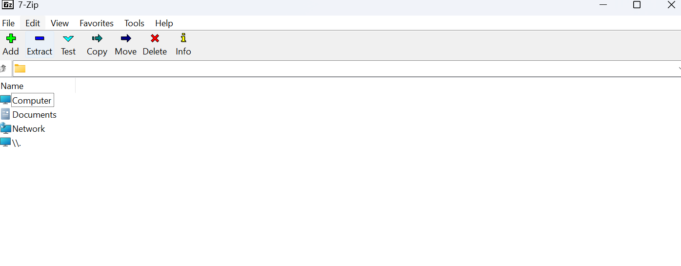
Download and install 7-Zip from https://7-zip.org/download.html. Record the installed version: 26.5.0.0.

Step 2 — Install VirtualBox
Download and install VirtualBox from https://virtualbox.org/wiki/Downloads. Record the version installed: 7..2.22.
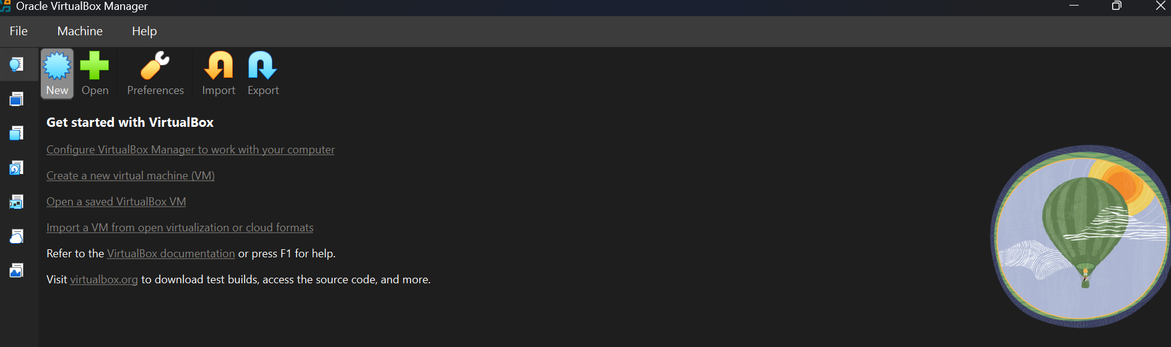

Step 3 — Create the NAT Network
In VirtualBox network settings, create a NAT Network with the subnet 10.0.0.0/24. Record the NAT Network name and settings: Network 10.0.0.0 Net Mask: 255.255.255.0/24.
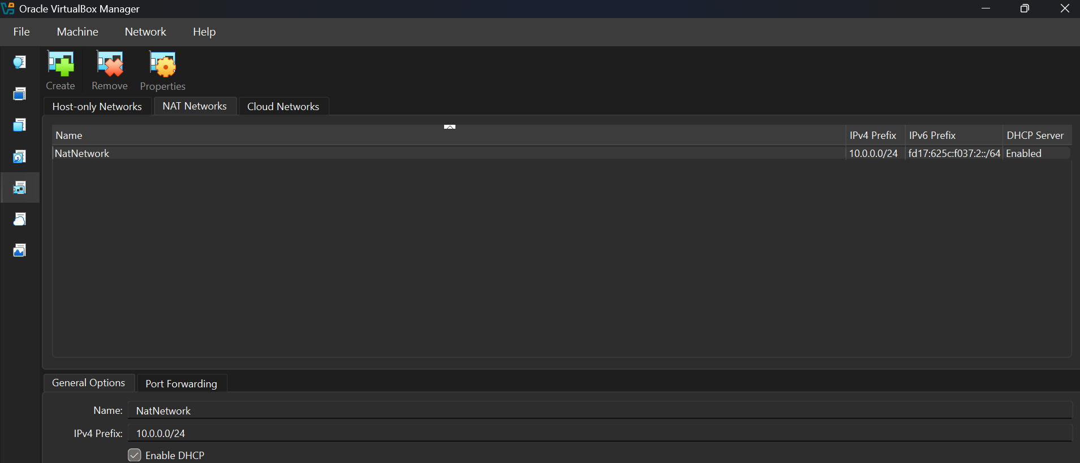

Step 4 — Download and Import Kali Linux
Download Kali Linux from https://kali.org/get-kali and import the virtual machine into VirtualBox. VM name: Version 2026.2 x64
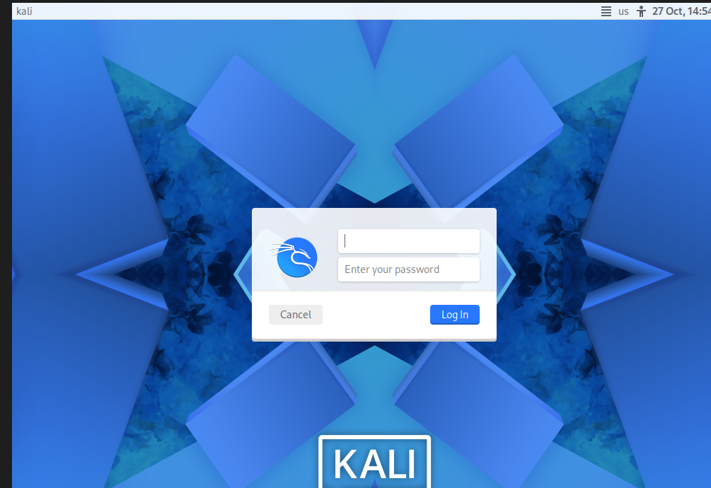

Step 5 — Configure Kali Linux IP Address
Configure the Kali Linux network interface with the required address 10.0.0.2/24 on the NAT Network. Record the interface name and configuration method:
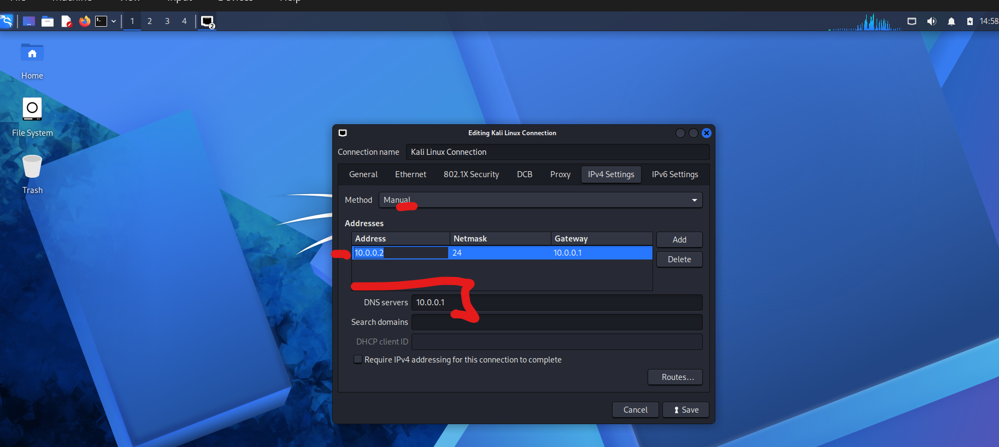

Step 6 — Take a VM Snapshot
Create a snapshot of the configured Kali Linux virtual machine.
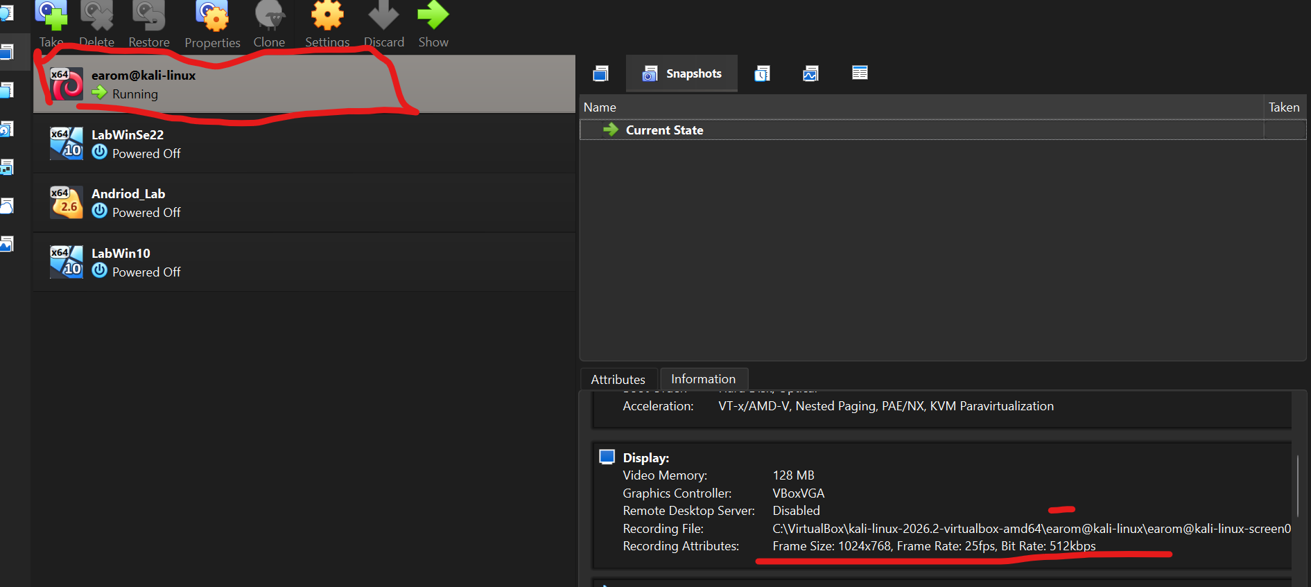
4. VirtualBox and Kali VM Settings
Use these sections to document the configuration shown in your screenshots. Do not mark a requirement complete until you have checked it in your own environment.
[ Screenshot: VirtualBox NAT Network settings ]
Show network name, network enabled status, and subnet 10.0.0.0/24.
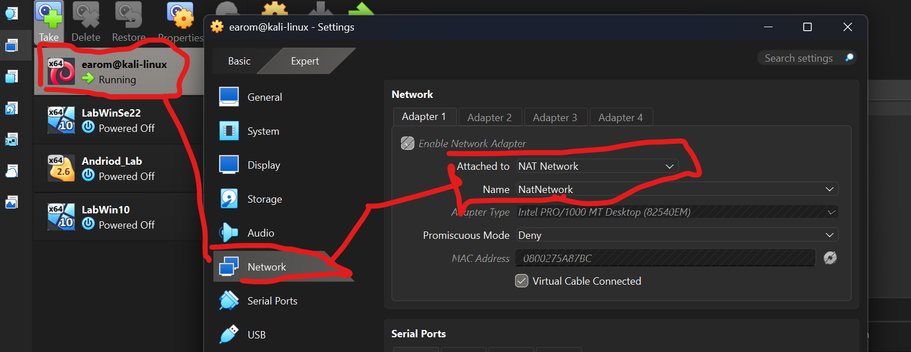
Evidence / notes: _________________Kali Linux NatNetwork_____________________________________________

Explanation / result: [Briefly describe what the screenshot proves and any issue encountered.]

Explanation / result: [Briefly describe what the screenshot proves and any issue encountered.]

Explanation / result: [Briefly describe what the screenshot proves and any issue encountered.]

5. Verification and Results
Complete the checklist after testing your setup.
☐ VirtualBox installed and opens successfully.
☐ NAT Network is configured for 10.0.0.0/24.
☐ Kali Linux VM is imported and boots successfully.
☐ Kali Linux is configured with 10.0.0.2/24.
☐ Shared clipboard is enabled.
☐ Drag-and-drop is enabled.
☐ Host /downloads folder is shared with the VM.
☐ Kali Linux has Internet access.
☐ A snapshot of the configured VM has been created.

Test results
Test | Expected / required result | Your result
IP address | 10.0.0.2/24 | [Pass / Fail + evidence]
Subnet | 10.0.0.0/24 | [Pass / Fail + evidence]
Internet access | Working | [Pass / Fail + evidence]
Snapshot | Created | [Pass / Fail + evidence]

6. Troubleshooting (if Kali has no Internet)
The supplied PDF recommends checking the NAT Network, confirming network settings, ensuring no other VM is using 10.0.0.2, and restarting the VMs / host if needed.
For VirtualBox 7 with Kali Linux 2026.1 or newer, the PDF lists these commands as a possible fix:
sudo nmcli connection modify "Wired connection 1" ipv4.dad-timeout 0
sudo nmcli connection down "Wired connection 1"
sudo nmcli connection up "Wired connection 1"
Troubleshooting performed (if any): [Describe the issue, action taken, and result. Do not claim a fix unless you tested it.]
[ Screenshot: Troubleshooting evidence (if applicable) ]
Note that there are no issues encounters during the setup and installation
Evidence / notes: ______________________________________________________________

7. Phase 2 — Optional Extension
The source PDF describes this as optional for future tasks: install Windows 11/10/7 or Android 9x in VirtualBox, ping-test the machines against each other, and take snapshots.
☐ Optional additional VM installed: [name/version]
☐ Ping tests performed between VMs: [summarize]
☐ Snapshots created for optional VMs: [summarize]
[ Screenshot: Optional VM / ping test (if completed) ]
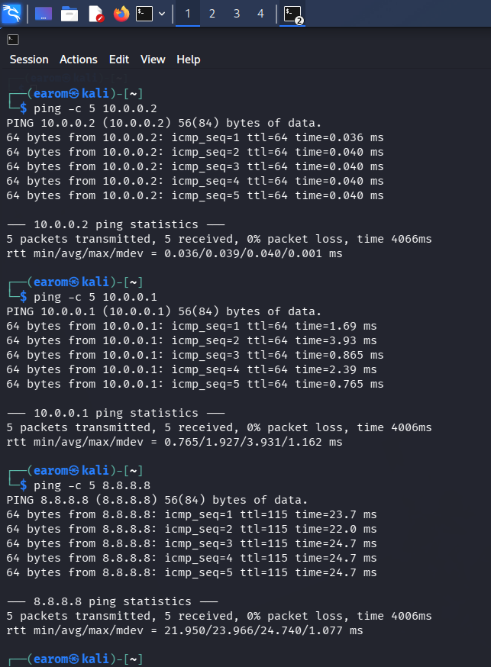
Evidence / notes: ______All ping test successful______

8. Conclusion
Write a short conclusion based on your actual results. Mention whether the required lab components were configured successfully, which tests passed, and any remaining issues.
During the lab setup, installation, configuration and testing no issues were found. All ping tests were successful.

9. Submission Checklist
☐ Student details completed on the cover page.
☐ All bracketed prompts replaced or removed.
☐ Relevant screenshots inserted and labelled.
☐ Results reflect tests actually performed.
☐ Spelling and formatting checked.
☐ Document saved with an appropriate filename.
Source: WK1-PM1 — Week 1, Project Module 1: Lab Setup VirtualBox and Kali Linux, version 4.2 (user-provided PDF).

